

From the desk of Pastor Murdy…

**Brother Martins Small Catechism Part III**

**The Creed Article I**

“Faith is a living, daring confidence in God's grace, so sure and certain that a man could stake his life on it a thousand times.” - Martin Luther

Following the Ten Commandments we begin to learn where our faith is grounded. The foundation of our faith is the belief that God exists as Father, Son and Holy Spirit. The Holy Trinity. The Trinity is one of the greatest, most perplexing and most fundamental mysteries of our faith as Christians. Believing in the Trinity is what sets us apart as people of the book, those who hold faith in the God of scripture- Islam and Judaism. Christians, Jews and Muslims are all monotheistic (believing in the ONE-same God). What makes us different is understanding God as three in one. God revels Godself through creation and human history. Through the coming of Christ and his death on the cross. And through the church as we are led and supported by the Holy Spirit.

Luther begins to teach this great mystery as a basic and fundamental belief for the church through the Apostle’s Creed. The Apostle’s Creed has three parts (what we call articles). Article I, God the Father. Article II, God the Son. Article III, God the Holy Spirit. We begin with Article I.

I believe in God, the Father almighty

Creator of heaven and earth.

Each section of the Small Catechism offers a simple explanation as to what something means. Before the explanation we have the classic Lutheran phrase, *“What is this and what does it mean?” Martin Luther teaches us: “I believe that God has created me together with all that exist. God has given me and still preserves my body and soul: eyes, ears, and all limbs and senses; reason and all mental faculties. In addition, God daily and abundantly provides shoes, clothing, food and drink, house and farm, spouse and children, fields, livestock, and all property- along with all the necessities and nourishment for this body and life. God protects me against all danger and shields and preserves me from all evil. And all this is done out of pure, fatherly, and divine goodness and mercy, without any merit or worthiness of mine at all! For all of this I owe it to God to thank and praise, serve and obey him. This is most certainly true!”*

Friends, it doesn’t get simpler than that! First and foremost we acknowledge God as our Father and Creator. The ONE who gives us life and supports that life with all that we are and all that we have. Everything we have comes from God. Everything! Our ears, senses, and soul! Our clothing, property and family! Luther teaches us that God does all of this out of pure fatherly grace- in other words, just because he loves us! How do we respond to these kinds of gifts?

Continued…

**2016 Council Officers**

President- Bob Thompson

Vice President- Kelly Braun

Secretary- Venus Thompson

Treasurer- Bob Thompson

***2016 Council Members***

Christian Education- Venus Thompson

Fellowship- Karen Houseman

Social Ministry- Joel Randal

Finance- Clay Marnich

Evangelism- Bill Hendricks

Stewardship-

Property- Bob Thompson

Worship/Music- Jerry Wessel

Comm./Publications- Dale Kozek

Youth Ministry- Joel Randal

**NEXT COUNCIL MEETING**

Tuesday, October 11th

at 7:00 PM

*ASCENSION LUTHERAN CHURCH*

*The Messenger October 2016 Issue*

Continuation…

“For all of this I owe it to God to thank and praise, serve and obey him.” As Christians we must constantly and daily evaluate how we respond to God’s gracious gifts to us. To live a life of thanks is to recognize life as a precious gift. How do you thank God? Do you use words, use actions, caring for others, giving to the needy, or prayer? How do you praise God? Do you praise with your life, regular worship, prayer, or in studying scripture? How do you serve God? When you serve is it with generous hearts and hands, time and talent, treasure and trust? How do you obey God? Do you honor God in your heart- loving and serving only God? Do you put God first above all else? Do you love one another as God has loved you?

As we continue our journey through the Luther’s S.C. let us be mindful of where we find ourselves now and be open to where God’s Holy Spirit will lead us. To believe in God is to acknowledge first that we are not alone and that by ourselves we can do nothing. God has given us life and daily sustains that life with all we need. Let us live thankful lives.

Yours in Christ+

Pastor Joseph Murdy, TSSF

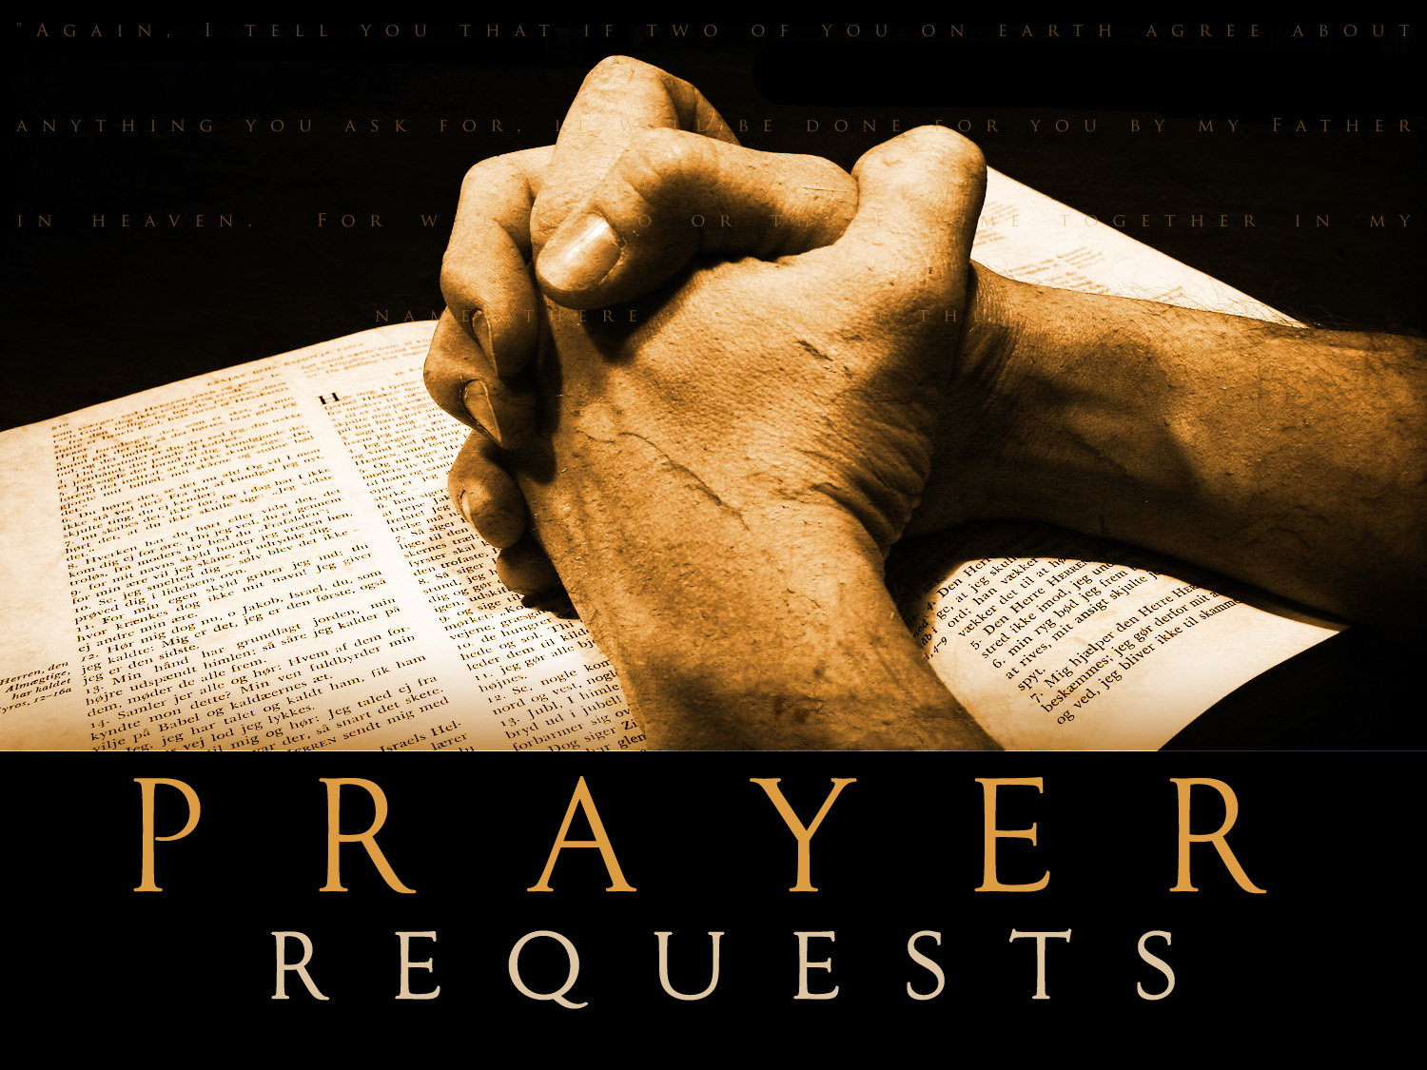

Shirley Vete; Pat and Gene Summerhill; Mary and Harold Honath; Ron and Pat Williams; Elizabeth Reuben; Sandy Belsky; Lorraine Zwikl; Dan Moniot; Barbara Jean Murdy; Dan Moniot; Judy Mostoller; Dale Kozek; and Rich Mussman.

# A Message from Rich…

"Come to me, all you who are weary and burdened, and I will give you rest."

Matthew 11:28 NIV.

    Many of us lead busy, hectic, and often stress filled lives. We rise early in the day, get children off to school, get ourselves ready for work, and spend a day at an occupation that at times we don't even like and become stressed. Even if we enjoy our occupation it can cause a degree of anxiety at some point. Even if we do not have children living with us, or are retired or whatever our situation may be there

are many days when life just becomes a burden and can be overwhelming. In this above scripture quote our Lord Jesus implores us to bring it all to him, all of it. He teaches that our burdens are too much for us and we need to give them all to him. He wants all of them, all the anxiety, all the stress, all the chaos that consumes us when raising a family or trying to meet expenses, or recovering from illness. He sees all, he knows all, he understands us better than we understand ourselves. He cares for us, he has empathy and compassion for us and wants us to come to him with our fears, our problems and issues that we deal with in everyday life. He promises to take them from us, to lighten our yoke. He is present, always present with us waiting for us to hand

over our burdens. But the decision is ours. We must make the decision to come to our Lord.

    So why not avail ourselves of the love, compassion, and understanding of the Master himself. Give it all to him, all of it, and leave nothing out.

God bless. R

**Rich Mussman**

**Blessing of the Animals**

Join us on Saturday, October 23rd at 12:30PM. Bring your critters and furry friends of all sizes to the church to receive a special blessing. No Snakes please! If it is a nice day we will worship outside and if the weather is not as favorable we will gather inside. Our pets are always a blessing to us and asking for God’s blessing serves as a reminder of the gift they are to each of us.

Memorial Fund

When a loved one dies, how do we remember them? This question is especially important when a saint of the church dies and people whose lives were touched want to honor God in whom they rest and who provided such a gift- for however short a time. In the like of the church when a loved one dies we have the opportunity to contribute to the memorial fund.

Additional Ways to Give Towards the Church…

SIMPLY GIVING:

Simply giving is a new and much more suitable way to give to your church. Many of us pay our bills online or have them set up to be paid automatically for convenience. Now you can give to the church the same way. You simply fill out a form indicating how much you would like to give a week, bi-weekly, or monthly and it will easily be withdrawn from your bank account.

THRIVENT MEMBERS:

The Thrivent Choice Program lets members choose where some of Thrivent Financials charitable outreach funds go. If you are a Thrivent member who is eligible to participate in this program, you can choose Ascension to receive your choice dollars. To learn more, please contact church office.

**Worship:** If you have an interest in decorating the church during special times of the year please see Lynn Kinney or Pastor Joe. We are looking for your talents and ideas on how we can decorate the church to be more festive and display symbols related to the season. For example during Advent, Christmas, Lent, Easter, Thanksgiving, etc.,

We would love to work together!

**Music:** Have you ever wondered how hymns are selected and why we sing certain songs when we do? If you are interested in helping in the music selection process please see Pastor Joe or Brandy. As part of our three year mission plan we would like to invite more participation in the planning process. Let us know!

**NEW**- We invite you to share your favorite hymns with us that can be incorporated in our worship. Hymnals are available in the narthex, along with a sheet for you to list your favorites. Feel free to borrow a hymnal to spend more time with your selections.

*Worship and Music*

**Children’s Church**

It is with sadness that we announce in this month’s newsletter that we will not be offering children’s church for the remainder of the year. Although we love offering this great ministry to our young children during regular worship we were unable to find the necessary amount of volunteers needed to continue throughout the year. My hope is that this will change in the 2017 and we will be able to once again offer children’s church with consistency. I ask for your prayers for this great ministry and the rest it will take.

In the meantime, we have many other opportunities for young faith development and growth. Our nursey is always open during worship so that children and parents can remain a part of our communal worship. We offer two kinds of youth bulletins: reader and prereader. These are available every Sunday with our regular bulletins and are new every week based on the lessons for the day. We also offer our kids bags which continue to be utilized.

Finally, a word to our parents with squirmy kids. Relax! God put the wiggles and the giggles in our little ones and we love having them be a part of worship. Bringing your children to church is so vital and important to their faith development and we hope that you find our worship fun, relaxed and welcoming to people of all ages!

**

**

*Ascension is happy to announce that we have teamed up with Happy Feet for fall 2016*

*The season kicks off Tuesday, September 20th (5:30-6:30 PM)*

[*www.happyfeetpittsburgh.com*](http://www.happyfeetpittsburgh.com)

**Ascension Lutheran Church is changing hymnals!**

We ordered 88 of the needed 140 new Lutheran hymnal, the Evangelical Lutheran Worship (ELW) or Cranberry book. We welcome you to contribute to this effort by donating a book to the glory of God in honor or in memory of someone. Each hymnal cost $22.50. We invite you to use the envelopes provided in the bulletin.

**WE ARE $1170.00 AWAY FROM OUR GOAL!** THANK YOU ASCENSION FAMILY AND FRIENDS!

** 

**

FALL Soccer Season!

**Carla Stewart, Director**  
WHO: All kids ages 2-8 **\***Mini (ages 2-3); Classic (3-5); Premier (ages 5-8)

WHERE: Ascension Lutheran Church

WHEN: Our 8-Week season starts Wed. Sept. 7th at 5:30 PM and Sat. Sept. 10th at 11:40 AM

*Multiple, convenient class times from which to choose!

* Please visit our website for more information

<https://www.soccershots.org/pittsburgh/>

***UPCOMING COMMITTEE/MEETINGS***

**Finance Meeting**

Monday, October 3rd at 7:00 PM

**Communications/Publications Meeting**

Monday, October 17th at 7:00 PM

**Lunch Bunch**

Thursday, October 20th at 11 AM

**Mutual Ministry Meeting**

Sunday, November 6th at 9 AM

***Saying good bye. Not now. But soon!***

*“For everything there is a season, and a time for every matter under heaven…a time to weep, and a time to laugh…” Ecclesiastes 3:1,4a*

There is no easy way to share this and no easy way to say goodbye. If you haven’t heard already our awesome and talented Office Administrator Nicole along with her family will be leaving us by the end of the year. What she has contributed to the life, ministry and daily operation of Ascension is immeasurable! Nicole’s husband Peter is a Master Sergeant in the US Air Force and from time to time in “season” they must move and embrace the next adventure. The Shenot family came to us a little less than two years ago from San Antonio and we’ve always known that we would have to say goodbye someday. Their next destination is the Scott Air Force base in Fairview Heights, Illinois. Nicole and Peter received notice of their move a few weeks ago and have slowly been breaking the news to loved ones. We have had too many laughs to count, a few tears in-between. Oh! I could tell you stories about the office antics!

Nicole and her family will be with us through the rest of the year and will most likely be moving in January after the holidays. So, we have her for just a few more months. A few more tears and a ton more laughs. She has truly made all the difference and continues to put the joy in en‘joy’able work! *Even though she and the boys are moving and this makes us sad, we wish them all the very best on the next chapter of their family story. We thank you Nicole for all of your hard work. For the dedication and faith that you put behind every effort and for making all the difference in the life of our Church. Saying goodbye doesn’t have to be sad because for those who are connected by the love of God in Christ Jesus it simply means, “May God bless you and keep you, until we meet again.”*

*Love and Blessings+*

*PJ*



**Ascension Supports**

**"Family Promise" at Sewickley United Methodist**

If you are interested in learning more and/or getting involved (volunteering as a van driver, dinner host, evening host, or overnight host), please contact Lynn Neilson (lynnneilson@gmail.com) and Ellen Randal (ellen.randal@gmail.com). To learn more about Family Promise, visit their website at [www.familypromiseswpa.org](http://www.familypromiseswpa.org).

When families successfully leave our Shelter program for housing of their own, our Home Again program sets them up with the furniture and household goods they need to make a successful new start!

We are desperately seeking mattresses and box springs of all sizes, but twin beds for kids are most important! They are also looking for gently used car seats.

**We pick-up!**

Please contact Laura Vincenti at [lvincenti@familypromiseswpa.org](mailto:lvincenti@familypromiseswpa.org),

412-576-9795 or 724-229-1129.

**

*The Fellowship Chart has been posted in the Narthex and is ready to receive sign-ups from members who are eager to provide a light snack after worship! Just take a look at the available dates and sign up for the date that works for you!*

*Important Dates:*

*Please mark your calendars stay tuned for Oktoberfest events coming soon!*

**

*We are always looking for non-perishable foods, small amount gift cards, and hygiene products for our*

*Brother Martin Pantry*

*If you know of anyone in need, please refer them to the church office. Thanks Ascension!*



When the Bible was first written, there were no chapters or verses as today. In fact, many of the early, handwritten manuscripts were written without spaces between the words! Stephen Langton divided the Bible into chapters about A.D. 1228. The Old Testament was divided into verses by R. Nathan in A.D. 1448, and Robert Stephanus divided the New Testament into verses in A.D. 1551. The first complete Bible with chapter and verse divisions was the Geneva Bible of A.D. 1560.





**Faith and Society**

“Faithful participation in society is integral and vital to the mission of the Evangelical Lutheran Church in America.” - [Social Statement Church in Society: A Lutheran Perspective](http://www.elca.org/en/Faith/Faith-and-Society/Social-Statements/Church-in-Society)  
  
The ELCA is a church that believes God is calling us into the world — together. As part of this call, we seek the common good for society, provide moral vision and are committed to addressing social and cultural injustices and issues. The ELCA participates in God’s just and loving purpose for all of creation in many different ways, from the daily actions of members as citizens, to efforts in social service, to public witness for justice.   
  
In response to God’s gracious love that seeks justice, the ELCA equips and nurtures us for our callings in the world, fosters social service and ministries of mercy, encourages learning and moral deliberation around social and cultural concerns, enacts social teaching and policy documents, interprets and applies social policy, and partners with agencies, organizations and institutions dedicated to service and justice.

 If you are interested in purchasing flowers to be placed in the chancel to the glory of God, we invite you to sign up in the Narthex on the flower chart. (Please ONLY place your name if you are ordering flowers) Checks can be placed in the offertory plate or church office, check are to be payable to Ascension Lutheran Church. The cost for two vases is $50. This is a great way to celebrate a milestone or loved one! The whole month of October and November is available.

**Lutherans commit to criminal reform**

By Ann Rodgers Pittsburgh Post-Gazette

In an overwhelming vote followed by cheers and a standing ovation, the Churchwide Assembly of the Evangelical Lutheran Church in America called for sweeping reform of the nation's criminal justice system and committed the church to ministry with and advocacy for prisoners and their families, victims of crime and ex-convicts.

"The ELCA is prompted to speak and to act because so many cries of suffering and despair emerge from the criminal justice system -- from victims, the incarcerated, their families, communities, those wrongly convicted, they who work in the system -- and have not been heard," the statement said. It was adopted 882-25 by the body whose weeklong meeting at the David L. Lawrence Convention Center ends today.

"A fundamental transformation of mind-set about criminal justice is required that challenges the logic equating more punitive measures with more just ones. Individuals must be held accountable, but every person in the criminal justice system deserves to be seen and treated as a member of human communities, created in the image of God and worthy of appropriate and compassionate response."

The 38-page statement "The Church and Criminal Justice: Hearing the Cries," calls for an end to privately run prisons, saying they undercut rehabilitation and have an economic motive to keep people locked up. The report focuses on keeping nonviolent offenders out of jail, trying to rehabilitate those inside and helping ex-convicts to live an honest, productive life. It says that lifelong sanctions, such as depriving felons of the right to vote or to obtain federal student loans, are counterproductive.

When possible, the report said, courts should use "restorative justice," where perpetrator, victims and members of the community work out a plan together to repair harm done by the perpetrator. It recommends alternatives to incarceration for nonviolent crimes, particularly drug and parole violations. It endorses a variety of sentencing reforms, including specialized courts that enable treatment for addicts and mentally ill people. The document also criticizes draconian sentencing guidelines, such as mandatory minimum sentences and three-strikes laws, and says that the nation's drug policies must be reformed.

The report was in the works for five years, with grass-roots hearings, and was familiar to the nearly 1,000 voting members. The only significant debate involved wording in a section on racial disparities in drug arrests. A proposed amendment would have changed the words "black" to "African-American" with amendments to the amendment then proposing "people of color" or "persons of African descent."

"I'm not African American, I'm black. I was born in the United States," said Maya Gaines from Maryland.

In the end, "black" remained in the sentence in question, though African American is used elsewhere in the statement.

After the vote, Bishop Kurt Kusserow said that the ELCA Synod of Southwestern Pennsylvania works through Christian Associates of Southwestern Pennsylvania to provide extensive ministry at the Allegheny County Jail and mentoring after inmates are released. The centerpiece is Pods of Hope, an interfaith program that provides inmates with instruction on life skills, such as parenting and budgeting, along with faith development in a voluntary community that sets higher standards for behavior than the rest of the jail.

"It's been so successful in Allegheny County that it's spreading to other counties," he said.

The Rev. Donald Green, an ELCA pastor who oversees the prison ministry as executive director of Christian Associates, said the document identifies serious problems that the jail chaplains see every day.

The inmates are "by an overwhelming majority non-white and charged with substance abuse-related offenses and should be in some other form of treatment than incarceration," he said. "This statement lifts up the need for major reforms. In Pennsylvania, finances are already beginning to force us to do some of it, because we can't afford to keep locking people up."

FOLLOW US ON

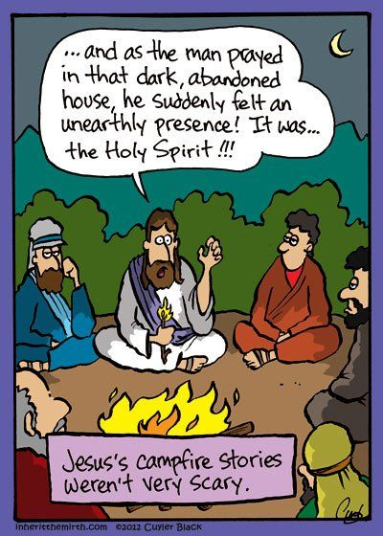

*Inside this Month Issue…*

*A Message from Rich*

*Soccer Shots*

*Fellowship*

*Upcoming Events*

*Birthdays and Anniversaries*





******************************************************************************

**Body love and roller derby**

I lay on my back on the cold concrete, legs a sprawl, and arms outstretched, laughing and gasping – both exhausted and exhilarated. When I sat up, the women with me pointed admiringly at the smear of sweat I had left on the concrete floor. I had just finished skating 27 laps around the track in less than five minutes! I marveled at my body.  When I was younger, I hated how my body looked and I hated the way it worked. I developed this hate/hate relationship with my body. I was always the kid who had to sit out gym class because of my asthma. My earliest memory is learning how to use an inhaler. I think, in our culture, it can be hard to have a positive relationship with our bodies. My heart aches for those in our midst, especially teenagers, whose minds are filled with unhealthy images of the body they think they are supposed to have. Instead of hearing that they are “wonderfully made” (Psalm 139:14), these children and adults are confronted with shaming expectations and taught to hate and fear their own bodies. Countering these messages can be literally lifesaving. Now, when I look in the mirror, what I see is a powerful and amazing creation of God. What made the difference for me?

Roller derby. 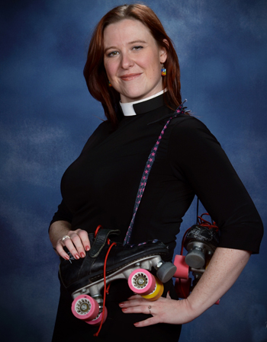

In 2013, after skating with the preschool children in the congregation I was serving, I remembered that I had loved to roller skate when I was younger. I was struggling with self-image at the time, but rolling around the rink with the little ones reminded me of joy and light.

After that outing, I bought a pair of cheap skates and took some Saturday-morning classes. But then I realized that my large thighs and powerful hips were not created for figure skating.

And then . . . derby happened.

Read the complete article at: <http://www.boldcafe.org/blog/body-love-roller-derby>

Ascension Lutheran Church

1290 Silver Lane

McKees Rocks, PA 15136

(412) 859-3711

[office@alcpgh.com](mailto:office@alcpgh.com)

[music@alcpgh.com](mailto:music@alcpgh.com)

[pastor@alcpgh.com](mailto:pastor@alcpgh.com)

[www.alcpgh.com](http://www.alcpgh.com)