

**2015 Council:**

* Clay Marnich, President
* Rick Zoltun, V. President
* Venus Thompson, Secretary
* Ellen Randal, Youth Ministry
* Bill Hendricks, Social Ministry
* Lynn Neilson
* Rudy Marnich, Finance
* Kelly Braun, Stewardship
* Dale Kozek, Communications
* Pastor, Worship/Youth

**Next council meeting will be Tuesday, November 10th at 7:00 PM.**

**Inside this issue:**

Message from Rich Mussman

Birthday and Anniversaries

Upcoming Events

Prayer List

Community Information

From the Pastor—

“There are six days when you may work, but the seventh day is a holy day, a Sabbath of rest, a day of sacred assembly.”

Lev. 23:3

When it comes to rules we tend to interpret them ourselves and follow them as we see fit. That light was orange! 65mph, that’s just for the right line! We all tend to bend the rules now and then when it comes to modern day traffic laws. How about the Ten Commandments? When was the last time you sat down to make sure you are in harmony with the ten things God requires of you?

At our recent Bishops convocation we talked about Sabbath. The convocation is an annual educational retreat for pastors from our Synod. What we call Sabbath today is our modern day Sunday. From the moment God issued this commandment it has been the day we worship and rest. Some people see the Sabbath as a whole day set apart from the week that is centered around worship, family time and rest. Others interpret Sabbath as several times throughout the week that are carved out for personal time. Whether it’s a Sabbath day or Sabbath rest we often fail to obey it. Why is that? Do we see it as God’s suggestion, or God’s Commandment?

As the Third Commandment it is part of a larger network of rules that God gives to His children. We don’t lie (at least we know it’s wrong when we do), we don’t steal, we worship the One true God, and we don’t kill. Each of the commandments are as Jesus says, “written on our hearts.” They are ingrained in us as human beings who are born with a moral sense of right and wrong. Is the call to Sabbath not also written on our hearts?

The 10 Commandments fall into two categories. 1-3 have to do with our relationship with God, and 4-10 have to do with our relationship with our neighbor. When we find ourselves in conflict with 4-10 we can sense the tension right away. Isn’t that true as well for the first three Commandments? How many of us feel the distance from God when we stop coming to church? When we stop praying? When we curse God’s name? When we fill our schedules and run ourselves down with busyness and then complain we have no time for God?

We are the keepers of our schedules. We say what goes on and what comes off. If you feel the pull from God and the distance that follows, maybe it’s time to think about Sabbath. If you are tired, busy, and full of stress, maybe it’s time for a Sabbath. As your pastor I admit that I am terrible at taking time to rest and recoup. Together we must learn to put God first at home, at work, and at church. Put God first in your calendars, let everything else come after. We have everything to gain, and nothing to lose. Be encouraged: “Come to me, all you who are weary and burdened, and I will give you rest.” Matt. 11:28

“For six days, work is to be done, but the seventh day shall be your holy day, a Sabbath of rest to the Lord.” Ex. 35:2 “The Son of Man is Lord of the Sabbath.” Matt. 12:8 “There remains, then, a Sabbath-rest for the people of God; for anyone who enters God’s rest also rests from their own work, just as God rested from His.” Heb. 4:9-10

Yours in Christ+

Pastor Joseph Murdy

**November 2015**

The messenger

Ascension Lutheran Church Newsletter, NOVEMBER 2015



 *Veterans Day Service at Mt. Calvary Cemetery (1715 Middletown Road, McKees Rocks, PA) on November 11th at 1:00 PM (in case of inclement weather the service will be held in the chapel located on the cemetery grounds) hosted by Good Shepherd Lutheran Church.*

Ascension Thanksgiving Service- please join us, here at Ascension, on Tuesday, November 24th at 7:30 PM.

This year we will be hosting our annual Community Thanksgiving Service. Following the service there will be a time of Fellowship with cookies and punch. If you are interested in making cookies, please see Pastor Joe or contact church office.

November 8th- The Kids will take part in leading the Worship service on this Sunday. Youth are invited to stay after church for a pizza party.

**Noisy offering, after our regular offering, the children will walk around with pots and pans to collect change that will be donated to the ELCA. Please remember to bring your change. **

A Message from Rich…

**I recently read a notice in our Ascension worship bulletin from 10/26/1980 in which the writer addresses the issue of noise in the sanctuary prior to worship. It states that although people are encouraged to visit, to please do so quietly, in a low whisper, or even better in the social hall. It seems that things have not changed much or perhaps gotten worse since then. The noise level in our sanctuary has risen sharply in the past few years. I was taught in the Church that the sanctuary is the house of the Lord and should be respected and honored as such.  Time spent prior to worship is intended to prepare us for the great event that is about to happen, the Lord Himself is coming.  It is not intended to catch up socially with people.  This is the purpose of the social hall.  Quiet conversation is appropriate, but not to the level of a yard sale. In the scriptures there are 61 specific admonitions to silence. In addition, there are 36 specific references to being still. God is telling is something, are we listening? I have had friends come to worship and they ask why is there so much noise in our church?  Yes we are friendly as we should be, but time prior to worship is intended as preparation for worship. Our children are not the problem as their parents are teaching them well. I would ask that we all think about this situation and pray on it.  I understand that no one intends to distract anyone intentionally, but I felt this issue needed to be brought to light. It’s as if we have an elephant in the room and everybody ignores it.**

**I speak for myself in this article, although there are others who feel the same way but have chosen to remain silent. It is not my intent to offend anyone, as this is my church and you are my family. We have a problem and it needs to be addressed.**

**God Bless.**

**Rich Mussman**

**November 2015**



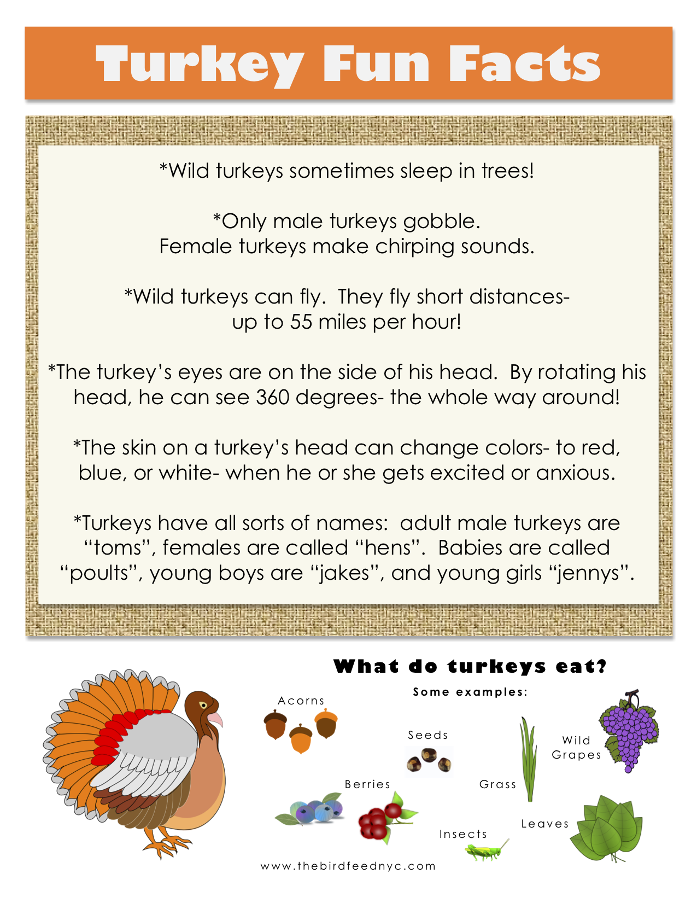

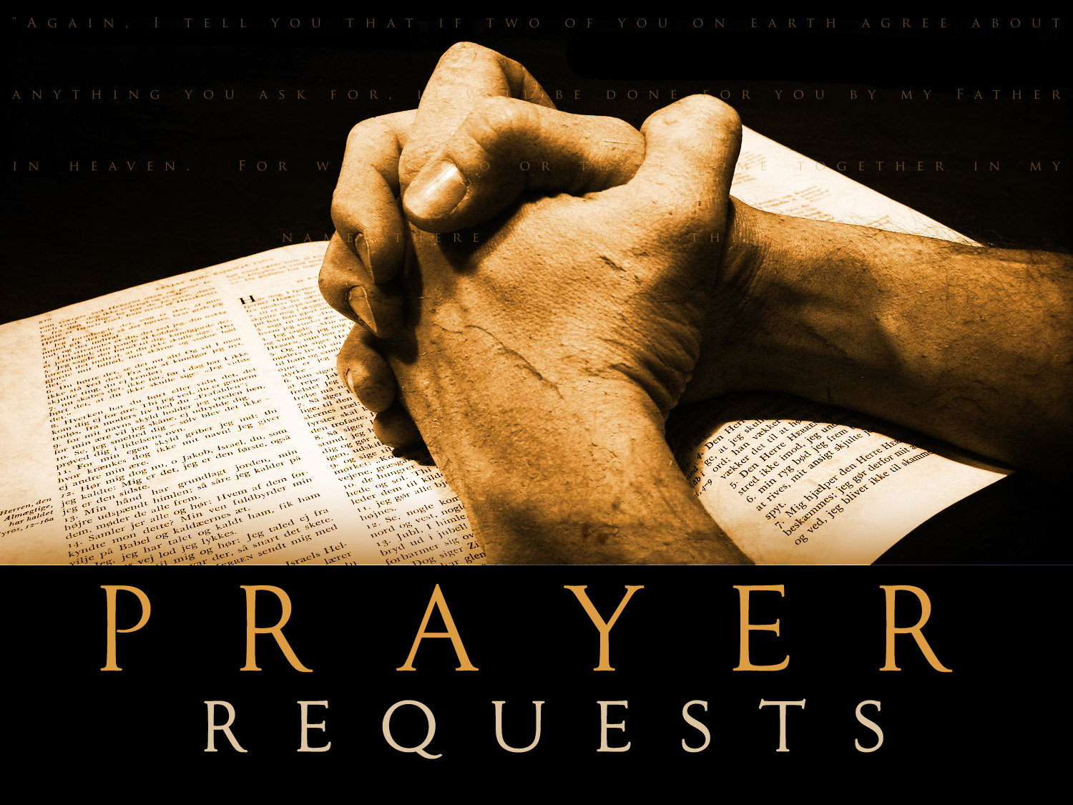

Shirley Vete; Pat and Gene Summerhill; George and Julia Kasich; Mary and Harold Honath; Ken “Butch” Thompson; Chuck Kohnen; Courtney Kohnen; Ron and Pat Williams; Elizabeth Reuben; Sandy Belsky; Dee Gratzmiller; Matt Wilkinson; Jean Nau; Aaron Braddick; Kay Braisted.

**We Give Thanks**

Our Father in Heaven,   
We give thanks for the pleasure; of gathering together for this occasion. We give thanks for this food; Prepared by loving hands. We give thanks for life, the freedom to enjoy it all   
and all other blessings. As we partake of this food, we pray for health and strength; to carry on and try to live as; you would have us. This we ask in the name of Christ, Our Heavenly Father.   
  
- Harry Jewell

**Our New Nursery**

We now have a beautiful nursery which gives parents and children a safe place to worship without the anxiety of interruption. We are asking for volunteers to help watch children during worship so that parents have the opportunity to sit in church. A Sign-Up sheet is in Narthex, Thank you to everyone for your support and thank you to the parents who decided one day that it was possible.

**November 2015**





**Altar Flowers for**

**November Weekends Available**

11/08/15

11/29/15

***COMMUNITY BOARD***

**Christmas Tree Light Up  
Visit with Santa  
Friday, December 4, 2015  
6:30-7:30 p.m.  
Clever Road Park**

Santa and Mrs. Claus will arrive at the Christmas Tree Light Up by fire truck and Santa will flip the switch to start the holiday season and light up Robinson Township! Join the festivities that will include caroling, hot chocolate and cookies. Make Robinson Township's Light Up event a tradition in your family and create holiday memories with us that will last for years to come!

CHRISTMAS CRAFT SHOW  
Holy Trinity School Building  
Saturday, November 14, 2015  
10 AM to 3 PM  
5720 Steubenville Pike, Robinson Township  
100 crafters – Lunch available  
Handicapped Accessible  
Tables available – 412-787-1822

**Beaver County Festival of Trees**

Come see the beautiful decorated trees at Bradys Run Park Lodge in Brighton Township. Walk into a Winter Wonderland and be amazed with a wide variety of creatively designed Christmas Trees displayed each with a different theme. Visit the North Pole Cafe', Santa Land, Candy Lane gift shop, enjoy the model train display with local entertainment. Free shuttle service from the Ice Arena.

Adults $5; Seniors $4; Children 6-12 $2.

Thursday 5-9pm; Friday-Sunday 12-9pm

Visit: www.beavercountyfestivaloftrees.org for more information!

If you are interested in purchasing flowers to be placed in the chancel to the glory of God, we invite you to sign up in the Narthex on the flower chart. (Please ONLY place your name if you are purchasing flowers) Checks can be placed in the offertory plate or church office, check are to be payable to Ascension Lutheran Church. The cost for two vases is $50.

**November 2015**

[](http://www.alcpgh.com/)

Please help the church in keeping our “Brother Martin’s Pantry” stock full for those in need! We have been able to help so many thus far. So the next time you are at the grocery store, grab just one more can of soup, canned vegetable or fruit, or even a box of pasta and a jar of sauce. *We are also accepting personal hygiene products.* Every little bit goes a LONG way and your constant support helps tremendously in someone’s life daily! THANK you, *for all you do*, Ascension Family!

**Memorial Fund**

When a loved one dies, how do we remember them? This question is especially important when a saint of the church dies and people whose lives were touched want to honor the God in whom they rest and who provided such a gift- for however short a time. In the life of the church when a loved one dies we have the opportunity to contribute to the memorial fund. After our 2015 annual meeting we established a memorial fund committee to help educate and oversee the receiving and use of funds contributed. If you are interested in being a part of this conversation, please see the Pastor. Gifts given to the memorial fund can either be designated for a particular item or use, or it can be left to the church to decide how to best utilize those donations. If you have questions about this process you can contact the office at any time. If you wish to make a donation in memory of a loved one cards are available in the **narthex.**



**Simply Giving:**

Have you been wondering what simply giving is? Simply giving is a new and much more convenient way to give to your church. Many of us pay our bills on line or have them set up to be paid automatically for convenience. Now you can give to church the same way. Simply giving is a program offered through Thrivent Financial and a company called Vanco. You simply fill out a form indicating how much you would like to give a week, bi-weekly, or monthly and it will easily be withdrawn from your bank account. You can even establish how much you want to give for Christmas, Easter, benevolence, local and other. It’s easy and simple- that’s why they call it *simply giving*. Nicole, pastor and others will be available to you if you have any questions. We encourage anyone who is interested. This enables us to track giving more efficiently, secures giving during the low months and helps with that Sunday morning dilemma “I forgot my check book.” Forms will be available beginning in September and will be available throughout the year for you to start any time.

**THRIVENT MEMBERS:** The Thrivent Choice program lets members choose where some of Thrivent Financials charitable outreach funds go. If you are a Thrivent member who is eligible to participate in this program, you can choose Ascension to receive your Choice Dollars. Thank you to those who have already designated their Choice Dollars to Ascension! For any questions concerning the Thrivent Choice Program, please contact your Thrivent representative or call Kurt Herbst, Ascension’s Thrivent representative at 724-814-6058.

**November 2015**

**November 2015**

Have you ever wondered what council is up to or what our finances are looking like these days? We invite you to see what going on by keeping up with our council minutes now available in the hall way and office. You may have noticed a new binder in the narthex. If you take a look inside you will see: a monthly council agenda and minutes, finance reports, team reports, our constitution and our annual bulletin of reports. If you wish to take a copy home you can find them located just inside the office on the wall in a folder marked council minutes. If you have any questions please feel free to ask your council representatives or pastor.

**Ascension Lutheran Church** 1290 Silver Lane  
 McKees Rocks, PA 15136

412.859.3711

[office@alcpgh.com](mailto:office@alcpgh.com)

[music@alcpgh.com](mailto:music@alcpgh.com)

[pastor@alcpgh.com](mailto:pastor@alcpgh.com)

[www.alcpgh.com](http://www.alcpgh.com)

Council Minutes Available!

newsletter text here.

