

**THE MESSENGER**

**2016 Council:**

* Robert Thompson, President
* Kelly Braun, V. President
* Venus Thompson, Secretary
* Joel Randal
* Jerry Wessel
* Bill Hendricks
* Karen Houseman
* Dale Kozek, Communications
* Pastor
* Treasurer Clay Marnich



**Next council meeting will be Tuesday, January 12th**

**at 7:00 PM.**

From the Pastor—

It has almost become customary at the close of the year to say, “Wow! That went fast!” Some years can seem longer than others. This year was one of those fast years! 2015 was marked with many different experiences for me, both personally and professionally. Some were full of life giving joy and others took more weight. As I look back at 2015 I am amazed at the lessons I learned and the ways I became grateful for God’s constant guidance at every moment.

I am most grateful for our community of faith, for your generous spirits and selfless love. As your Pastor I am incredibly humbled as I daily witness how God’s Spirit acts in and among us as the body of Christ here at Ascension. God continues to shape us, mold us, redeem us, fix us, and guide us. As people of God we must continue to train ourselves to be ever vigilant and determined to trust in God and allow Gods work to be done. One of the main logo’s for the ELCA is, “**Gods work. Our hands**.” In 2016, how can we become God’s hands in our community, in our church and in the world?

At the end of this year I am reminded of a saying by 15th century Christian mystic, Saint Teresa of Avila: **“Christ has no body now on earth but yours, no hands but yours,  
no feet but yours, Yours are the eyes through which to look out Christ's compassion to the world. Yours are the feet with which he is to go about doing good; Yours are the hands with which he is to bless people now.”** As we approach a new year, how can we better use our gifts, our hands, our feet, and our eyes to not only serve Christ but to be Christ in the world? The responsibility of the baptized is no easy task. But, it is one that is full of hope and promise. Christ promises to be with us always. As we prepare ourselves to take on a new year with new opportunities, joys, sorrows, hopes, challenges and visions let us do so with Christ in our hearts.

Happy New Year and may Gods peace reign in our lives as we live for Him in 2016!



Yours in Christ+

Pastor Joseph Murdy

***Ascension Lutheran Church***

***Newsletter January 2016 Issue***

**January 2016**

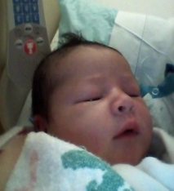**Congratulations!**

A Message from Rich…

**Are you making any resolutions for the New Year? If you are like most of us you will do so with a sincere resolve that will last at best a few weeks then temper off a little at a time. For those of us who are sincere and determined to make an honest effort at following through I offer the following simple and realistic resolutions: Let us all resolve to attend worship each Sunday. Think honestly how much you are able to contribute to the operation of our church. Why not resolve to participate in at least one of the many activities and programs Ascension offers throughout the year such as VBS, Wing Fling, or any number of our youth group activities? Perhaps you may wish to learn how to be a worship assistant or reader for our services. Maybe you would help to plant greens and flowers around the grounds. The list goes on and on. The opportunities for committing oneself to service are unlimited. And may I suggest these resolutions are the greatest ones you can make, because they are of service to God's ministry, and are extremely pleasing to Him. There are no more noble resolutions that to commit to service for our Lord and Savior.  Many blessings to you all in the New Year. God Bless.**

**Rich Mussman**

**January 2016**

Help us welcome the

newest addition to

Ascension’s growing

Family. Baby Elliot

Michael Woods. He was

born December 14th at 4:50 PM.

8 lbs. 13oz. and 20 ¾ long. Mom

and baby are healthy and doing

well. Dad and big brother are

overjoyed. We wish many

blessings to our Music Director

and her family.

**Congratulations and**

**blessings to Kathy Prince (our previous music director) and her daughter Emily on the birth of Emily’s son, Joseph Riggs Price, at 2:10 AM on Christmas Eve. 8 lbs. 14 oz. and 20 inches. Mom and baby are doing well.**

***Congratulations Ryan Williams***

*His parents are delighted to announce that Ryan graduated from New York Chiropractic College on December 5th, as a Doctor! Ryan is starting at a practice in Columbus, OH, at Columbus Chiropractic Center of Hilliard. On January 4th, Dr. Williams will start his career in caring and applying his healing touch to the community.*

**



Shirley Vete; Pat and Gene Summerhill; George and Julia Kasich; Mary and Harold Honath; Ken “Butch” Thompson; Chuck Kohnen; Courtney Kohnen; Ron and Pat Williams; Elizabeth Reuben; Sandy Belsky; Dee Gratzmiller; Matt Wilkinson; Jean Nau; Aaron Braddick; Kay Braisted; Lorraine Zwikl; Connor Paselivis; Rich Mussman and Debbie Hendricks.



***COMMUNITY BOARD***

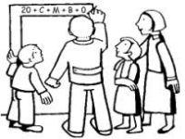**Blessing our homes in Epiphany**

During the season of Epiphany, which means “manifestation,” we hear the story of the Magi. These magi, later to be known as the three wise men followed a star at its rising from the east to a stable where they knelt to present gifts and witness the birth of a King, the manifestation of the Son of God incarnate. In this season of light we continue to celebrate the birth of Christ as our Savior and we mark this celebration with the blessing of our homes, offices, classrooms and churches. For many this is a new practice, or one that seems outside the scope of “Lutheranism.” This age old custom has been celebrated by Christians for hundreds of years and one we continue to embrace in our own tradition. At the start of Epiphany I will provide chalk and service sheets for you to bless your homes with your family. As your pastor I would be honored to be invited and grateful to stop by for a blessing of your homes. As we enter into this season on January 6th let us remember the visitors received by Christ and ask Christ to enter into our homes where his blessings and peace may be welcomed!

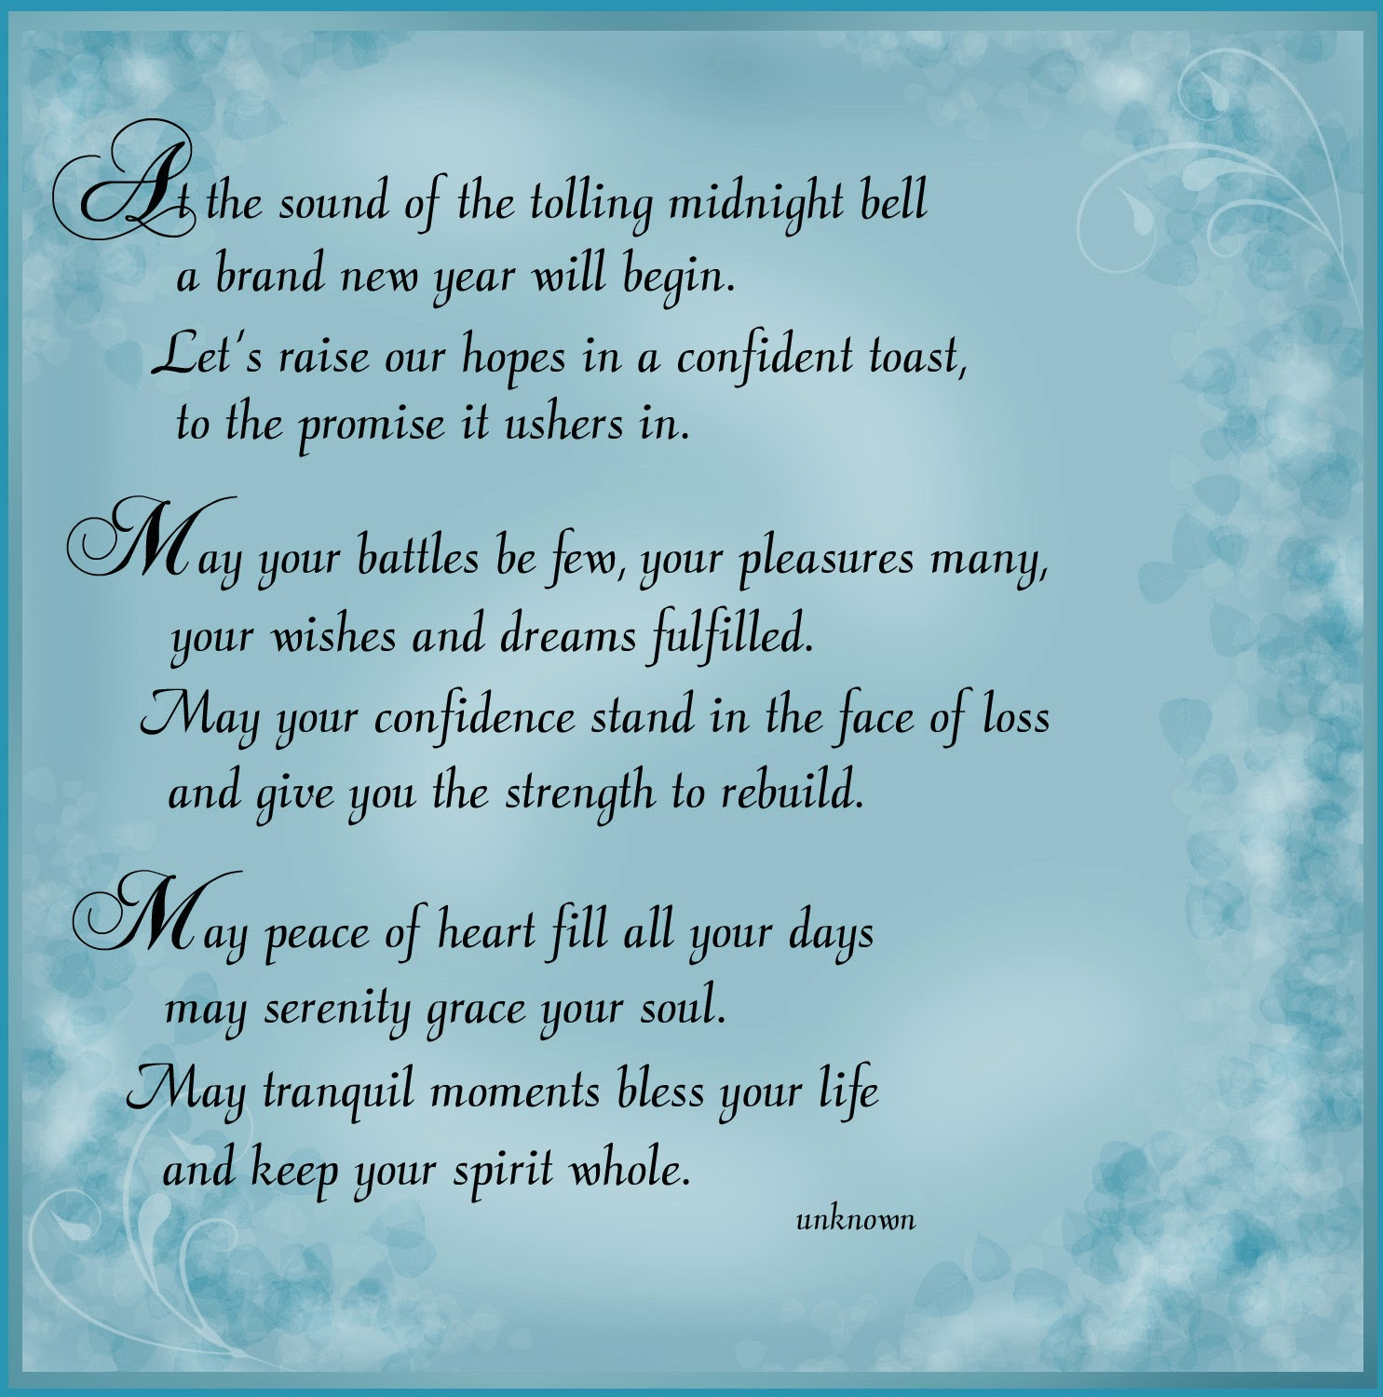

**January 2016**

[](http://www.alcpgh.com/)

If you interested in purchasing flowers to place in the chancel to glorify God, we invite you to sign up in the Narthex on the flower chart. (Please only place your name on the chart if you are purchasing flowers) Checks can be placed in the offertory plate or church office. Please make checks payable to Ascension Lutheran Church. The cost is $50 for two vases.

**SIMPLY GIVING:**

Simply giving is a new and much more convenient way to give to your church. Many of us pay our bills on line or have them set up to be paid automatically for convenience. Now you can give to church the same way. You simply fill out a form indicating how much you would like to give a week, bi-weekly, or monthly and it will easily be withdrawn from your bank account.

**THRIVENT MEMBERS:**

The Thrivent Choice program lets members choose where some of Thrivent Financials charitable outreach funds go. If you are a Thrivent member who is eligible to participate in this program, you can choose Ascension to receive your Choice Dollars



**We invite you to see what going on by keeping up with our council minutes now available in the hall way and office. You may have noticed a new binder in the narthex. If you take a look inside you will see: a monthly council agenda and minutes, finance reports, team reports, our constitution and our annual bulletin of reports.**

**Memorial Fund**

When a loved one dies, how do we remember them? This question is especially important when a saint of the church dies and people whose lives were touched want to honor the God in whom they rest and who provided such a gift- for however short a time. In the life of the church when a loved one dies we have the opportunity to contribute to the memorial fund.



2016 Year of the Monkey





**Congregational Meeting: Sunday, January 31st following worship.**

Inside this Issue…

A Message from Rich Mussman

Prayer List

Upcoming Events

Annoucemnets

Birthdays and Anniversaries

Pastor Murdy’s Article

**January 2016**

**Ascension Lutheran Church** 1290 Silver Lane  
 McKees Rocks, PA 15136

412.859.3711

[office@alcpgh.com](mailto:office@alcpgh.com)

[music@alcpgh.com](mailto:music@alcpgh.com)

[pastor@alcpgh.com](mailto:pastor@alcpgh.com)

[www.alcpgh.com](http://www.alcpgh.com)

